**COVID-19's Impact on Airport Traffic: Analysis of Traffic Volume Post-COVID**

**Description**

This report aims to analyze the impact of the COVID-19 pandemic on airport traffic volume using a dataset that shows traffic to and from the airport as a percentage of the traffic volume during the baseline period. The baseline period for this analysis is from February 1 to March 15, 2020. The dataset is updated monthly and is publicly available from Geotab (geotab.com).

**Data Overview**

Content

* The dataset provides the following key information:
* Traffic volume to and from the airport
* Percentage comparison to the baseline period (February 1 to March 15, 2020)
* Monthly updates to reflect changes over time

**Data Source**

The data utilized in this analysis is sourced from Geotab, a reliable provider of geospatial and telematics data.

**Inspiration**

Key questions for exploration include:

* Can you create a dynamic geospatial visualization of the traffic changes?
* How has airport traffic volume fluctuated over time since the onset of COVID-19?
* What trends can be observed in the recovery of airport traffic post-COVID?

**Analysis Framework**

1. Data Collection and Preprocessing

**Step 1:** Access and download the dataset from Geotab.

**Step 2:** Load the dataset into a data analysis tool (e.g., Power BI, Power query, Excel).

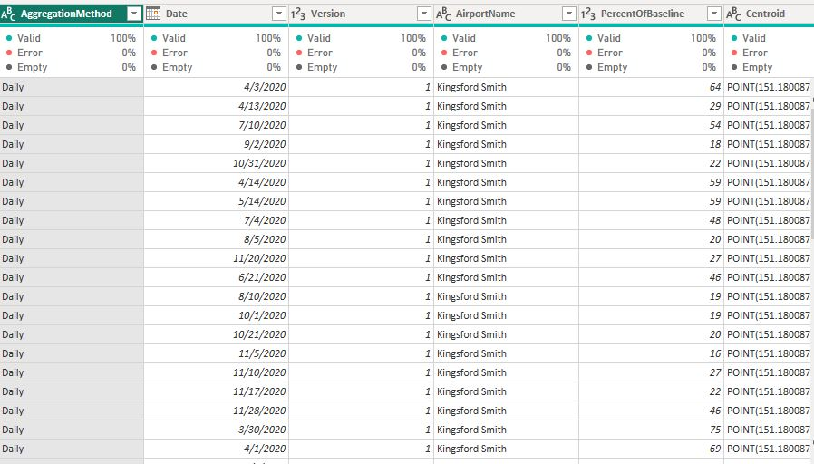

**Step 3:** Inspect the dataset for missing values, inconsistencies, and anomalies. Perform necessary cleaning and preprocessing steps by removing duplicate and changing variable format

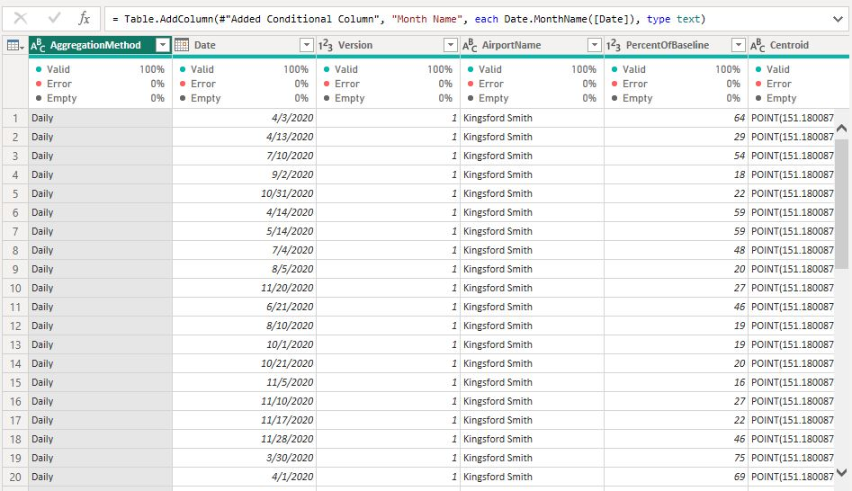

**Step 3**: Generate Calenda from the date data from the covid project to create a model

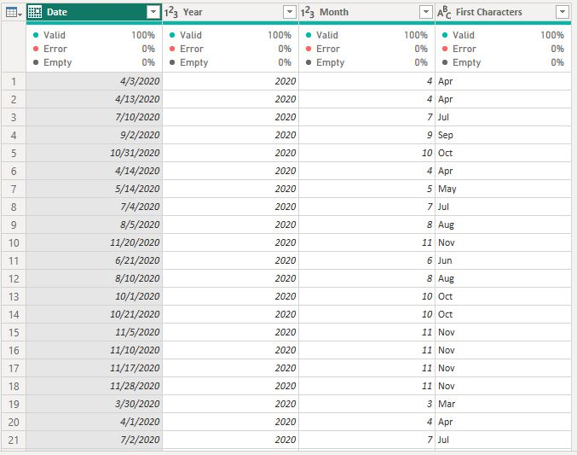

**Data Modelling**

The is a way of showing the relationship between variable in a Table. I separated the date row to form a calenda that I derive month, day and year from

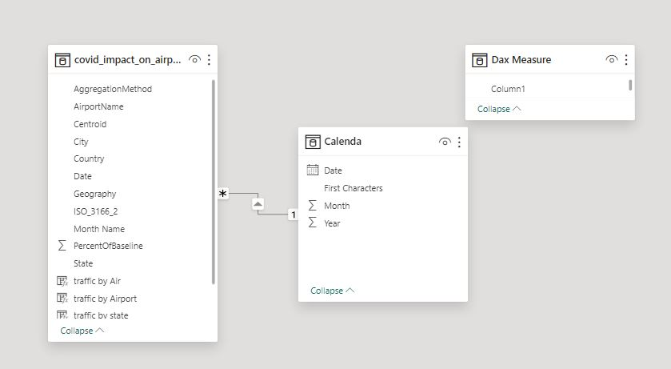

**2. Baseline Comparison**

**Percentage of traffic volume:** This means the current traffic is compared to the traffic during the baseline period (February 1 to March 15, 2020).

How the percentage works:

* If the current traffic volume is 50%, it means there is half as much traffic now compared to the baseline period or if is less an equal to 70% it means there is low traffic compare to the baseline
* If the current traffic volume is less and equal to 100%, it means the traffic is moderate and the same now as it was during the baseline period.
* If the current traffic volume is 200%, it means there is twice as much traffic now compared to the baseline period.

So, the percentage tells us how the current traffic level compares to what it was before COVID-19, using the baseline period as a reference.

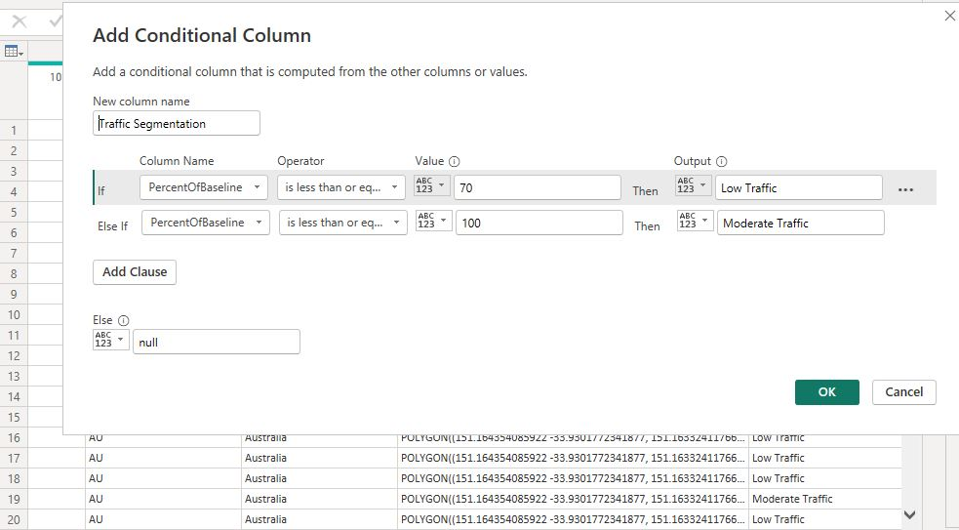

***Creation of additional conditional column to segment the low and moderate traffic***

**Step 1:** Identify the baseline traffic volume for the period from February 1 to March 15, 2020.

*The baseline traffic volume from February 1 to march 15m, 2020 is 7247*

**Step 2: Calculate the percentage change in traffic volume for each subsequent month compared to the baseline.**

Answer is on the **Dashboard**

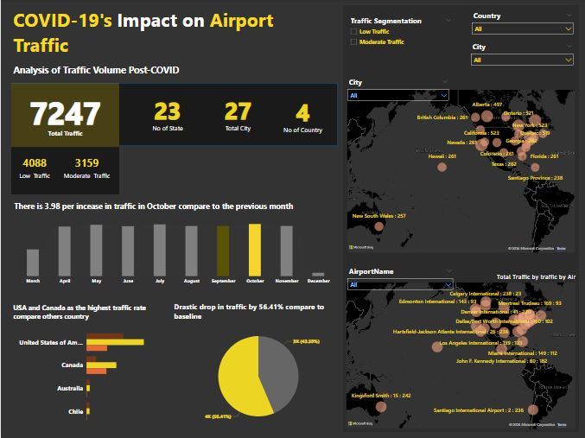

***Covid-19 Airport traffic Dashboard***

3. Trend Analysis

Step 1: Plot the monthly traffic volume percentages to visualize trends over time.

Initial Impact: There was a significant decline in airport traffic volume immediately following the onset of COVID-19, with the sharpest drops observed in April and May 2020.

**Step 2: Identify key** **periods of decline and recovery in traffic volume.**

*period of decline is around December while for recovery is starting from march to November*

**Step 3: Analyze the impact of major COVID-19 events and policies (e.g., lockdowns, travel** **restrictions) on traffic volume.**

*Covid-19 event results to Low movement of People*

**4. Geospatial Visualization**

**Geospatial Insights**

* Regional Differences: Certain regions showed quicker recovery rates, potentially due to domestic travel being less restricted compared to international travel.
* Hotspots of Decline: Major international airports experienced the most significant declines, while smaller regional airports showed more resilience.

Step 1: Use a geospatial visualization tool to create dynamic maps showing traffic changes.

Step 2: Highlight airports with significant changes in traffic volume.

Step 3: Create interactive features to explore traffic volume by month and region.

This can be view on the **Dashboard**

**5. Reporting and Insights**

**Step 1: Summarize key findings from the trend analysis and geospatial visualization**.

Answer is on the **Dashboard**

**Step 2: Discuss the implications of these findings for airport operations and planning**.

*Base on this data there will be low revenue generated and reduction in number of people traveling*

**Step 3: Provide recommendations for airport authorities and policymakers to manage future disruptions.**

*Adaptable Strategies: Airports should develop adaptable operational strategies to quickly respond to fluctuating travel demand.*

*Enhanced Safety Measures: Continued investment in health and safety measures to regain traveler confidence.*

*Diversification: Diversification of services and revenue streams to mitigate the impact of future disruptions.*

**Conclusion**

The COVID-19 pandemic has had a profound impact on airport traffic volumes, highlighting the need for resilient and flexible airport operations. This analysis provides valuable insights into traffic trends and offers recommendations for navigating future challenges. The dynamic geospatial visualization enhances the understanding of these trends and supports data-driven decision-making.

This report structure provides a comprehensive analysis framework, from data collection and preprocessing to trend analysis, geospatial visualization, and insights. It serves as a guideline to thoroughly understand and communicate the impact of COVID-19 on airport traffic volumes.